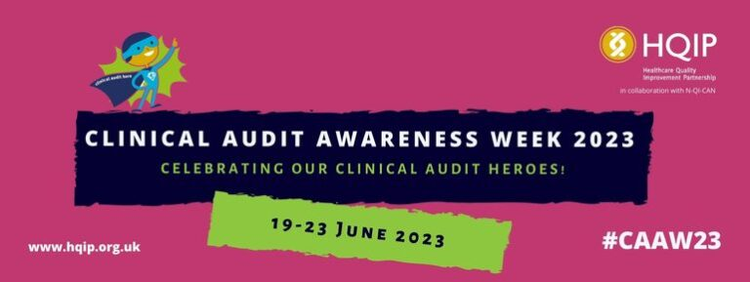
Clinical Audit Awareness Week 2023
The [TEAM NAME] team at [ORGANISATION NAME] is highlighting the role of clinical audit in improving patient care as part of a national campaign. Clinical Audit Awareness Week (which will take place from 19-23 June 2023) is an annual event hosted by the Healthcare Quality Improvement Partnership (HQIP) that celebrates the benefits and impact of clinical audit and quality improvement in health and care organisations, including hospitals, GP practices and hospices.
Clinical audit is a way to find out if health services are meeting local and national standards and targets. It lets care providers and patients know where their service is doing well, and where there could be improvements. The work of clinical audit teams is essential, both as drivers of improvement in their own organisations, and in terms of their contribution to national audit data collection that allows appropriate scrutiny of our health and social care system.
[NAME], [JOB TITLE] AT [ORGANISATION NAME], said: “By generating reliable data, clinical audits help to improve the care our patients receive. They provide evidence to show when we’re getting it right, but also help us to identify areas where we need to improve. That’s why we’re delighted to take part in Clinical Audit Awareness Week this year.”
Clinical Audit Awareness Week incorporates the Clinical Audit Heroes Awards where individuals and teams who make an outstanding contribution to clinical audit and patient care are recognised. The winners are announced during Clinical Audit Awareness Week.
Jane Ingham, Chief Executive of Healthcare Quality Improvement Partnership (HQIP), added: “Clinical audit gives patients and the public reassurance when making choices about their health care. There’s no doubt that clinical audit teams are among the unsung heroes of the health sector and the Clinical Audit Heroes Awards offer an opportunity to recognise the critical role they play.”
To mark Clinical Audit Awareness Week, the team will be [INSERT DETAILS ABOUT ACTIVIY TAKING PLACE IN THE RUN UP TO AND DURING THE WEEK]…
Don’t forget to share news of Clinical Audit Awareness Week on social media; look out for #CAAW23!
Notes
Clinical Audit Awareness Week is a national campaign hosted by the Healthcare Quality Improvement Partnership (HQIP) in collaboration with National Quality Improvement (including Clinical Audit) Network (N-QI-CAN).
More information is available at www.hqip.org.uk/clinical-audit-awareness-week. The social media hashtag is #CAAW23 (follow @HQIP on twitter for updates).

