
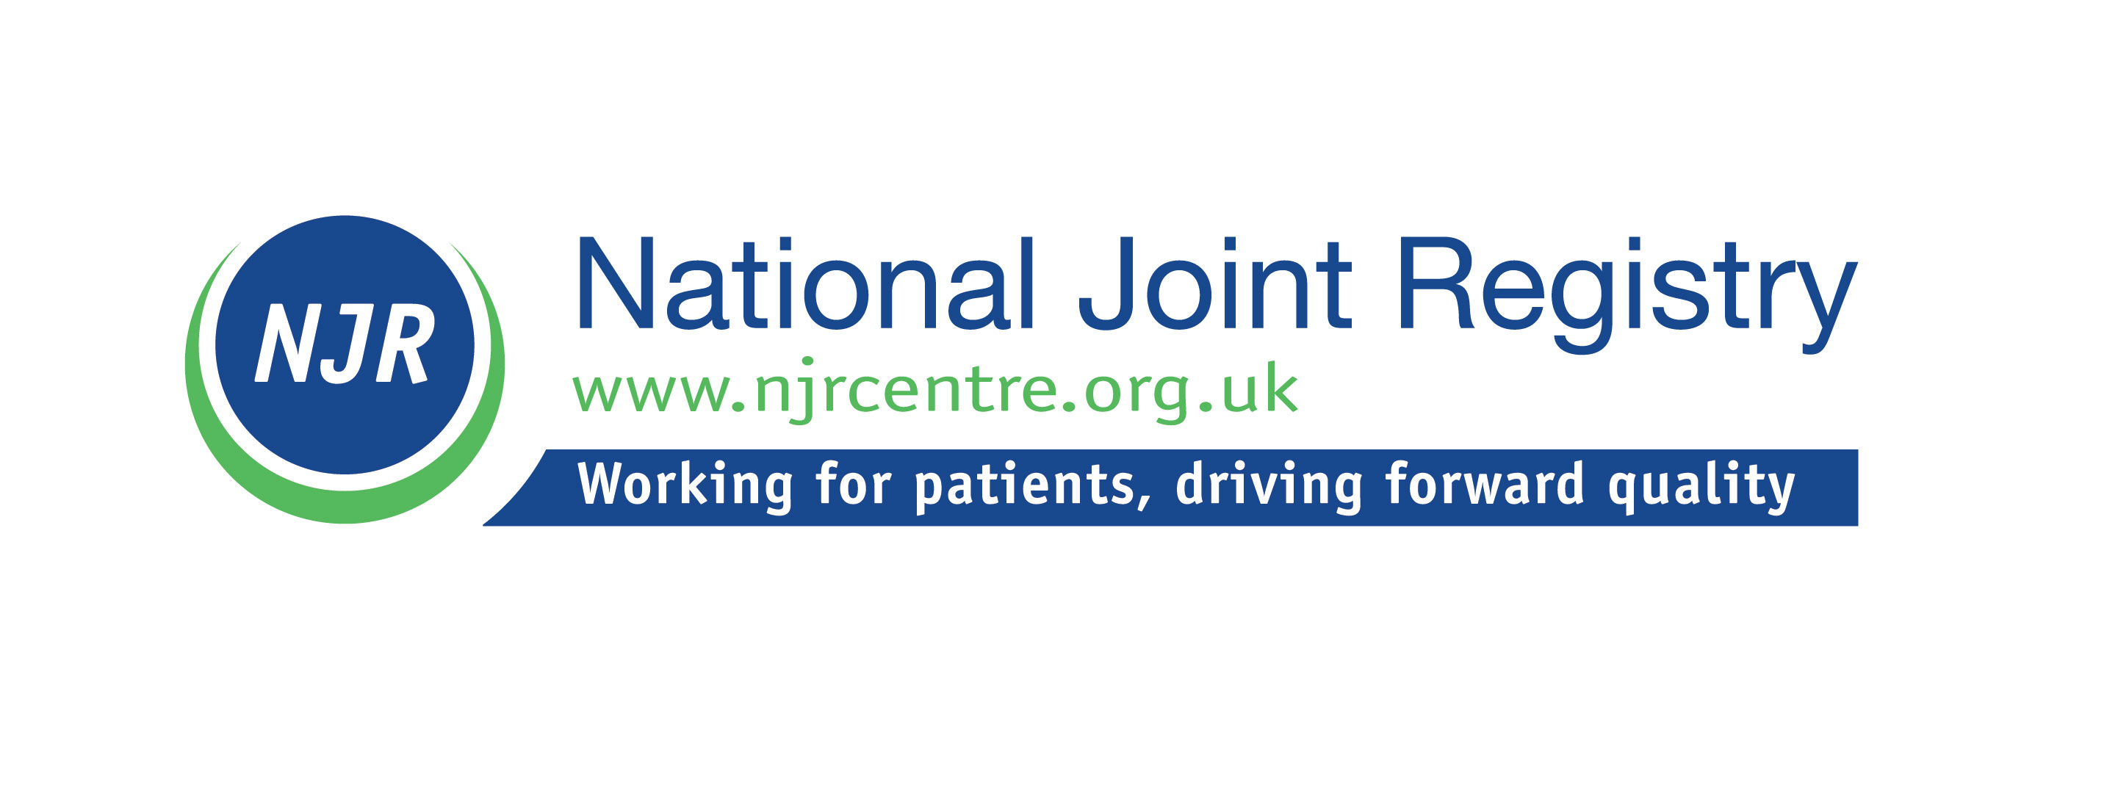

JOB DESCRIPTION

Job Title: | Operations Manager, Performance and Business Planning (NJR)
Reporting to: | Associate Director, Performance and Business Planning (NJR)
Accountable to: | Deputy Director of Operations, NJR and Chair of the Surgical Performance and Implant Scrutiny Committees
Salary : | circa £45,000
Contract type: | Permanent
Hours: | 37.5 hours per week
Location | Remote with occasional travel (expenses covered)

About the National Joint Registry

The National Joint Registry (NJR) collects information on hip, knee, ankle, elbow and shoulder joint replacement surgery and monitors the performance outcomes of joint replacement medical device implants, as well as surgical and hospital performance. Described as a global exemplar of an implantable medical device registry, the NJR, which covers England, Wales, Northern Ireland, the Isle of Man, and Guernsey, continues to be the largest orthopaedic registry globally and one of the most influential healthcare registries in the world, now with around 3.7 million procedure records submitted.

The key purpose of the registry is to collect high quality and relevant data about joint replacement surgery in order to provide an early warning of issues relating to patient safety. In a continuous drive to improve the quality of outcomes and ensure the value of joint replacement surgery, we monitor and report on outcomes on orthopaedic implants, hospitals and surgeons and we work across both the NHS and independent healthcare sector.

We are hosted by the Healthcare Quality Improvement Partnership (HQIP) and overseen by a Steering Committee (NJRSC), which is designated as an NHS England (NHSE) ‘Expert Committee’ and is responsible for overseeing the strategic direction of the NJR. There are currently eight NJR sub-committees, which support the work of the NJRSC: the Executive, Medical Advisory, Editorial, Surgeon Performance, Implant Scrutiny, Data Quality, Regional Clinical Coordinators and Research Committees. In addition, ad hoc working groups are convened for the purpose of specific projects and workstreams and vary in number at any one time, dependent on activity.

The NJR’s core services are managed under two main contracts; one for the collection and management of data and technology and the second for the provision of statistical support and analysis of data. This work supports NJR outcome monitoring, research activity and the production of NJR publications. The NJR also enables and supports wider orthopaedic-related research.

The NJR management team, led by the Director of Operations, oversees the day-to-day operational management, development and communication of the NJR’s work programme, supporting the NJRSC in providing governance and strategic oversight of the registry, including NJR sub-committees and contracts. Further information can be found at https://www.njrcentre.org.uk

Purpose of the position

This is a vital management role and the holder will be a key member of the NJR management team, contributing to the achievement of an effective and responsive NJR leadership office, operating within a busy and pressurised environment.

The post holder will work closely with, and will be accountable to, the Chairman of the Surgical Performance and Implant Scrutiny Committees, to ensure the efficient and adequate monitoring of Surgeon, Unit and Implant Performance. This will include management of a number of operational issues, project management, taking forward actions, chasing progress, amongst others.

Additionally, the post holder will work closely with the other Chairs of NJR sub Committees as may be relevant, to ensure the efficient and adequate management of a number of business planning issues and projects, taking forward actions, chasing progress and providing updates as required.

The post holder will be expected to provide support to NJR Committees as necessary.

Key responsibilities and duties
This post will be the lead Operations Manager for the following functions
Implant Scrutiny Committee

- To organise the drafting, approval and communication of implant outlier notification letters, monitor responses and update the Chairman and the relevant authorities as appropriate.
- To update and maintain records of all correspondence using the Outlier Management System (OMS).
- To manage the Implant mismatch monitoring and notification process.
- To manage the escalation processes to the appropriate authorities, e.g. MHRA
- To organise and attend the Implant Scrutiny Committee (ISC) and be responsible for agendas, minutes and action lists arising out of the committee or any working groups and other meetings relating directly to the committee.

Data Quality Committee

- To organise and attend the Data Quality Committee (DQC) and be responsible for agendas, minutes and action lists arising out of the committee or any working groups and other meetings relating directly to the committee.

Other working groups

- To organise and attend the Data Alignment Working Group (DAWG), Implant Reporting Unit Working Group (IRUWG) and other relevant meetings and be responsible for agendas, minutes and action lists arising out of the committee or any working groups and other meetings relating directly to the committee.

Business Planning

- Review, improve and implement appropriate systems to support the efficient and effective running of NJR Steering Committee and sub committees;
- Coordinate all committee management and administration, including ensuring that agendas, papers, action logs and minutes are provided in a timely, efficient and accurate manner;
- Assist the Associate Director for Performance and Business Planning in planning and undertake committee member recruitment and re-appointment exercises;
- Assist with the planning and delivery of induction programmes for new members and ongoing training activity, monitoring of committee member performance and planning of appraisals;
- Support the Director of Operations with succession planning for committee members;
- Ensure governance for committee related activities, information and databases are maintained including membership and attendance database, declarations of interest, confidentiality, handbooks etc.;
- Ensure that committee actions are appropriately recorded and reported and that performance against annual plan objectives are reported by committee leads into NJR Steering Committee;
- Maintenance of clear and navigable filing systems for all NJR files and folders; and
- Be responsible for recording and maintenance of up-to-date logs of committee member declarations of interest including working with members and the NJR Director of Operations to identify any potential conflicts that need to be managed or escalated.

General

- Identify areas and processes for improvement.
- Develop and maintain excellent professional relationships with internal and external stakeholders relevant to the working areas.
- Be prepared to give verbal and written updates of project progress at any stage in the project to the NJR Deputy Director of Operations, Chairman for the Surgical Performance, Implant Scrutiny Committee and Associate Director of Performance and Business Planning.
- Provide a flexible resource across all areas in the NJR; performing any ad hoc management activities for the NJR as required by the NJR Deputy Director of Operations and NJR Associate Director of Performance and Business Planning.

Project Management

- To manage the day to day activities of additional related projects under the direction of the NJR Director of Operations, Deputy Director of Operations and Associate Director of Performance and Business Planning and the Chair of Surgical Performance Committee, Implant Scrutiny Committees;
- To support the Associate Director of Performance and Business Planning in developing and maintaining detailed project plans and a risk register for each relevant work-stream and monitor progress towards key milestones, monitoring expenditure against agreed budgets, the management of relevant project documentation, and the organisation of close down activities at project completion;
- To ensure agreed action is taken in accordance with the project plan and liaise closely with others within the NJR who have been tasked with actions; and
- Co-ordinate the input of NJR contractors in delivery of the agreed projects.

This post will support another Operations Manager in delivery of the following functions
Surgical Performance Committee

- To perform the day-to-day management of work-streams related to the Outlier Management Process within the NJR annual plan, arising from NJR committees and daily operational activity, to ensure that objectives are met within the agreed timescales.
- To update and maintain records of all correspondence using the Outlier Management System (OMS).
- To draft, ensure approval of, and send surgeon and unit outlier notification letters, monitor responses and update the chair as appropriate.
- To manage the escalation processes to the appropriate authorities, including the Care Quality Commission.
- To organise and attend the Surgical Performance Committee (SPC), and be responsible for agendas, minutes and action lists arising out of the committee, or any working groups or other meetings relating directly to the committee.

Publication of Data

- To manage the NJR submissions for surgeon and unit level reporting in relation to the NJR surgeon and hospital website, unit Level CQC dashboard, National Clinical Audit Benchmarking and Model Health System.
- To ensure the timely and accurate publication of NJR reports and websites including NJR Annual Clinical Reports, Consultant Level Reports, Surgeon and Hospital Profile and Clinician Feedback.

Person Specification

 | Essential | Desirable | Tested through  A – Application  I – Interview  S – Assessment
Qualifications | Educated at graduate level |  | A
Knowledge and experience | At least five years’ experience in University, NHS or charity sector management  Experience in successful management of members of staff  Track record in successful management of projects and programmes  Experience of developing and implementing standard operating procedures | Prior knowledge of the National Joint Registry, National Clinical Audits or NHS management and/or healthcare provision desirable | A/I
Skills, aptitudes and abilities | Excellent writing skills and attention to detail  Excellent planning and organisational skills  Ability to prioritise and manage multiple tasks and working to challenging targets and deadlines  Excellent interpersonal and relationship management skills, ability to liaise with internal and external stakeholders and communities  Excellent communication skills  Analytical and problem solving skills  Excellent IT skills |  | A/I

