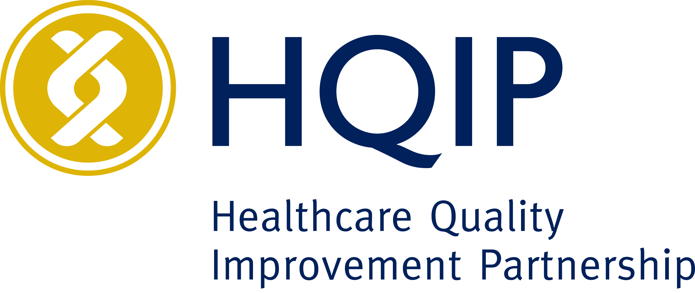

Job Description
Job Title: | Marketing lead
Reporting to: | Head of Communications & Marketing
Salary and scale: | £43,000 -50,000, to be pro rata to reflect part time hours.
HQIP Band | C
Contract type: | FIXED TERM 12-MONTHS  Homeworking - HQIP is a homeworking organisation with excellent IT support. Travel into central London is required on an occasional basis for scheduled corporate activity
Hours: | Part time 18-24 hours per week
Annual leave | 30 days plus public holidays (pro rata for part-time)
Pension | Company’s Group Personal Pension scheme  At time of recruitment employers contribution is 6%

About us
The Healthcare Quality Improvement Partnership (HQIP) is an independent organisation established to promote quality in healthcare and in particular to increase the impact that clinical audit has on health care improvement. We manage NHS clinical work programmes on behalf of NHS England and other devolved nations. This includes the National Clinical Audit & Patient Outcome Programme (NCAPOP) which consists of over forty National Clinical Audits and clinical outcome review programmes. We are supported by two parent organisations: the Academy of Medical Royal Colleges and The Royal College of Nursing.

HQIP work focuses on the following key strategic areas:
- using best management and procurement practice, we commission and contract manage the National Clinical Audit and Patient Outcome Programme and the National Joint Registry on behalf of NHS England and other healthcare departments and organisations
- we encourage wide use of robust data for quality improvement of care, offering patient choice, promoting patient safety, supporting revalidation and service accreditation, commissioning, service redesign, and research
- we inform and influence national healthcare policy by effectively communicating our work and that of our partners
- we support healthcare professionals to review and improve their practice by providing opportunities to share best practice
- we ensure that patients and carers are at the heart of our work through continued, strategic involvement in all relevant processes and projects.

To ensure its success HQIP will take full advantage of the connections and influence of the consortium partners to:
- promote engagement in clinical audit and quality improvement initiatives by healthcare professionals of all disciplines and specialties
- create national and local partnerships between clinicians and patients/service users to optimise the impact of clinical audit
- support local audit staff and create seamless links between national and local audit
- foster active dissemination and implementation of audit results
- ensure that evidence about participation in audit, and the results of audit, are used for secondary purposes, including for the revalidation of healthcare professionals
- encourage audit in areas of low activity and links with audits outside of the NCAPOP framework
- engage all relevant stakeholders
- develop and extend the work to make it a permanent feature of the landscape of healthcare quality regardless of the future of central funding of national clinical audit.

Further information can be found at http://www.hqip.org.uk/

Purpose of the position
HQIP is able to offer a range of services to healthcare organisations, branching out from our core services. We offer specialist procurement services with value-added components such as Patient and Public Involvement and Quality Improvement support, Quality Improvement consulting, insight and evaluation projects, and specialist Patient/Community Engagement support.
Marketing is a crucial tool for any organisation, playing a significant role in creating and maintaining a positive reputation, raising awareness of the services offered, and driving overall business growth. Effective marketing strategies help to connect with the target audience, communicate the value proposition, and differentiate the organization from competitors.
We need an energetic and creative marketing professional to work with us to increase our presence and awareness of what we can offer.

Key Responsibilities and duties
Strategy Development:
- Refresh and implement a comprehensive marketing strategy aligned with the organization’s new direction and goals.
- Lead the promotion of new services offered by the organisation.

Campaign Management:
- Plan, execute, and monitor marketing campaigns across various channels, including digital, social media, email, and traditional media.
- Focus on increasing brand awareness and driving new business.

Content Creation:
- Develop compelling and high-quality content for different marketing materials, including articles, blog posts, social media updates, newsletters, and promotional materials.
- Potentially support staff to author journal articles
- Create visually appealing graphics and design elements to support marketing content.

Market Research:
- Conduct market research to identify trends, opportunities, and customer preferences within the UK healthcare sector.
- Use insights to inform and refine marketing strategies.

Performance Analysis:
- Analyse the effectiveness of marketing campaigns using metrics and analytics tools.
- Provide regular updates with insights and recommendations for improvement.

Collaboration:
- Work closely with the Associate Director for QI and other internal teams to ensure cohesive and integrated marketing efforts.
- Influence and guide others in the organization to adopt marketing practices as part of their daily work.
- Develop staff engagement with marketing efforts

Brand Management:
- Maintain and enhance the organization’s brand image and reputation through consistent messaging and high-quality content.
- Ensure all marketing efforts align with the organisation’s intellectual, evidence-informed, and data-driven approach.

Person Specification

 | Essential | Desirable | Assessed through  A – application form  I – Interview  T – Assessment Test
Knowledge, skills and experience  Qualifications and skills | - A degree in Marketing, Communications, or a related field.  - Strong understanding of current marketing trends and best practices, particularly within the UK healthcare sector.  - Proficiency in digital marketing tools and platforms  - Excellent communication and interpersonal skills.  - Creativity and innovation in developing marketing strategies.  - Project management skills to handle multiple tasks and deadlines efficiently.  - Graphic design skills  - Website design and content management system (CMS) experience.  - Ability to produce high-quality, intellectual, and evidence-informed content. | Advanced degrees or certifications in digital marketing, healthcare marketing, or related disciplines are preferred. | A – Application form  I – Interview  T – Assessment Test
Experience | - Experience of working with the NHS and the UK healthcare sector is essential.  - Significant senior experience in marketing roles, with a proven track record of successful campaigns and strategies.  - Experience in both traditional and digital marketing is essential.  - Experience of using creativity to meet goals with minimal expenditure. | - Prior experience working in the not-for-profit sector is highly desirable. | A – Application form  I – Interview
Scope of responsibility / accountability  Breadth and level of responsibility, strategic input | The appointee will be expected to provide leadership of the marketing strategy, and provide options/ recommendations for action to senior leaders.
Autonomy  Freedom to act, decision making, problem solving, judgement | The marketing lead will work in coordination with the AD for QI as well as senior managers and the Communications team.  The marketing lead will need to show creativity and initiative to meet goals.
Resource management  People and budget responsibility | A small marketing budget will be available for materials.
Interfaces  Internal and external, routine vs relationship management | Representing the organisation externally during networking at on stalls at events etc.  Influencing internally to gain internal support for marketing plans.

