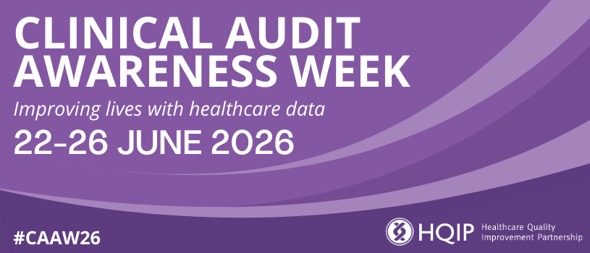
Clinical Audit Awareness Week 2026
The [TEAM NAME] team at [ORGANISATION NAME] is highlighting the role of clinical audit and other data-driven healthcare improvement in transforming patient care as part of a national campaign. Clinical Audit Awareness Week, which will take place from 22-26 June 2026, is an annual event hosted by Healthcare Quality Improvement Partnership (HQIP) that aims to improve and save lives by promoting and celebrating the critical role of clinical audit, registries and other evidence-based improvement.
Clinical audits and similar programmes are critical to the ongoing enhancement of healthcare quality and patient safety. They provide a clear view of what is working well and where improvement is needed most, enabling healthcare professionals to raise standards, reduce variations in care, and ensure every patient gets the best possible treatment. Clinical Audit Awareness Week 2026 will highlight their impact, encourage participation, and showcase success stories.
[NAME], [JOB TITLE] AT [ORGANISATION NAME], said: “By generating reliable data, clinical audits help to improve the care our patients receive. They provide evidence to show when we’re getting it right, but also help us to identify areas where we need to improve. That’s why we’re delighted to take part in Clinical Audit Awareness Week this year.”
Clinical Audit Awareness Week incorporates the Excellence in Clinical Audit Awards (formerly called the Clinical Audit Heroes Awards), which celebrate the individuals and teams who are transforming healthcare through rigorous audit and improvement projects.
Chris Gush, Chief Executive of Healthcare Quality Improvement Partnership (HQIP), added: “Every patient deserves safe, high-quality care, and clinical audit and similar evidence-based programmes help make that happen. The professionals who lead this work are essential to driving progress in healthcare, so the Excellence in Clinical Audit Awards shine a well-deserved light on their invaluable contribution.”
To mark Clinical Audit Awareness Week, the team will be [INSERT DETAILS ABOUT ACTIVITY TAKING PLACE IN THE RUN UP TO AND DURING THE WEEK]…
Don’t forget to share news of Clinical Audit Awareness Week on social media; join the conversation using #CAAW26.

Notes
- Clinical Audit Awareness Week is a national campaign hosted by Healthcare Quality Improvement Partnership (HQIP).
- More information is available at www.hqip.org.uk/clinical-audit-awareness-week and www.hqip.org.uk/excellence-in-clinical-audit-awards-2026.
- The social media hashtag is #CAAW26 – follow HQIP on LinkedIn, BlueSky and X for regular campaign updates.

